OVER VOLTAGE OR UNDER VOLTAGE TRIPPING MECHANISM

ABSTRACT
The aim of this project is to develop a low voltage and high voltage tripping mechanism to protect the load from damage. The fluctuation in AC mains supply is frequent in homes and industries. The sensitive electronic devices in these conditions can get easily damaged. It is preferable to have a tripping mechanism to protect the load.

This proposed system will trip the load in the event of the input voltage falling below/above a set value. Two 555 timers are used as window comparator. This delivers an error output if the input voltage to them crosses the range beyond the voltage window. A relay is then operated to cutoff the load for safety reasons. A lamp is used as load in this project.
The concept in future can be extended by integrating an alarm, which sounds when voltage fluctuations occur. It can also be interfaced with a GSM modem to convey alert message to the user via SMS to take appropriate action.
BLOCK DIAGRAM:

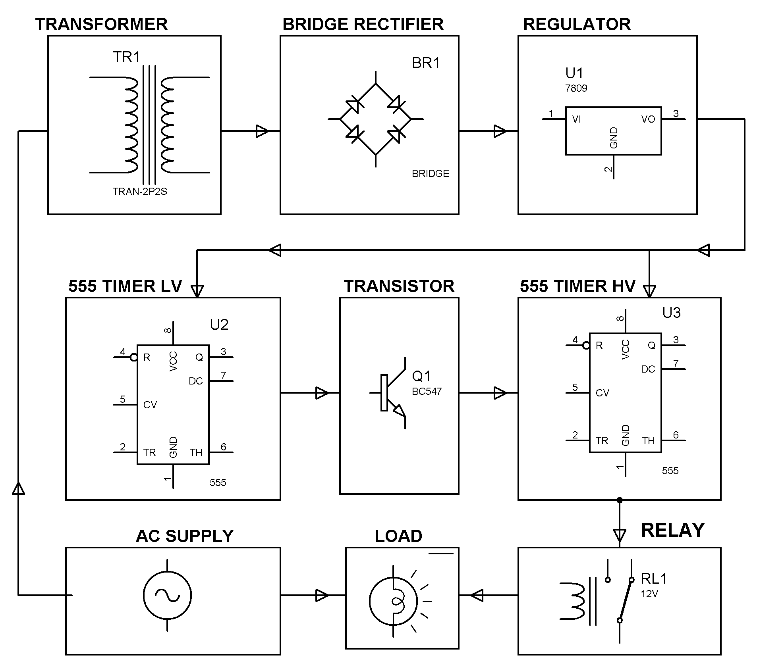

HARDWARE REQUIREMENTS:
555 Timers, LED, Voltage Regulator, Resistors, Potentiometer, Capacitors, Diodes, Relay, Lamp, Transformer.

